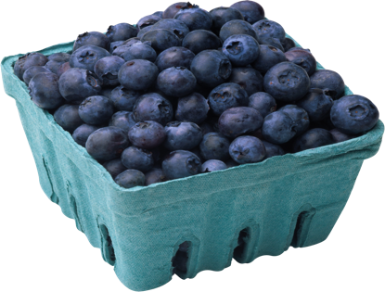
Fit To A Tee
This Photo by Unknown Author is licensed under CC BY-NC
At Home
With Coach K

Blueberries are everywhere. Visit a Farmers Market and get the freshest, sweetest berries you can buy. Explore the market. Talk to the farmers: they love to answer your questions. Then go home and make
BLUEBERRY, ALMOND, LEMON CAKE!!
You will need:
A loaf Pan 8 ½ X 41/2” You can buy a tin foil version in any grocery store or substitute an 8x8 pan.
Ingredients:
½ cup plus 2 TBLS room temperature butter
1 cup granulated sugar
2 medium lemons to get 2 tsps zest and 2 TBLS juice (DIVIDED)
1 tsp vanilla extract
3 large eggs, lightly beaten
2/3 cup all-purpose flour
½ tsp baking powder
1/8 tsp salt
¾ cup plus 2 tbsp ALMOND FLOUR (available everywhere now, in flour aisle)
7 oz fresh blueberries
½ cup confectioner’s’ sugar

HOW TO:
- Preheat oven to 400º Grease the pan and line with parchment paper
- Using a stand or handheld mixer, beat the butter, sugar, lemon zest, 1 TBLS lemon juice and vanilla on high speed for 3-4 minutes, until light. Then lower the speed to medium and add the eggs slowly. It might separate a little but WILL be ok. Mix the flour, salt, baking powder and almond flour together and add in three additions.
- FOLD IN , BY HAND, ¾ of the BLUEBERRIES. Scrape into the pan and smooth the batter out evenly.
- Bake for 15 minutes, then sprinkle the remaining berries over the top of the cake. Return to the oven for another 15 minutes, until cake is golden brown but still uncooked. Cover loosely with foil and continue to bake for 25-30 minutes. Test by inserting a knife into the middle: it’s ready if it comes out clean. Remove from oven and let cool in pan for 10 minutes. Remove from pan and place on a wire rack to cool completely
- Make icing: mix the confectioner’s sugar and the other tablespoon of lemon juice
Together. Pour over cooled cake spreading gently over the blueberries. YUM
NOTE: Use this time to talk about measuring and fractions. Your child can make this with YOU as his/her assistant!! Put out the tools and let them cook. Have Fun.

